How to search for electronic material on the Internet without dying in the attempt

Created by: David Rubio G.
Blog: https://soceame.wordpress.com/
GitHub: https://github.com/DRubioG
Last modification date: 09/03/25

It has always happened to us that when developing an electronic project we have found ourselves in the position of looking for electronic material and for this we resorted to Saint Google to show us the electronic material because we did not know the tools that would facilitate its search. Well, this post comes to solve this problem, for this we are going to expose the two key words that will help you to locate any electronic material belonging to the same type of electronics.
The key words are:
«<material to search> selection guide«
These two words allow you to access the explanatory document of the manufacturer in which it is detailed with tables, examples and descriptive images of the types of components that are needed.

Example
You want to locate a DC DC converter that allows you to raise the voltage from 3.6V to 5V. Well, to do this, in Google you type «DC DC selection guide»
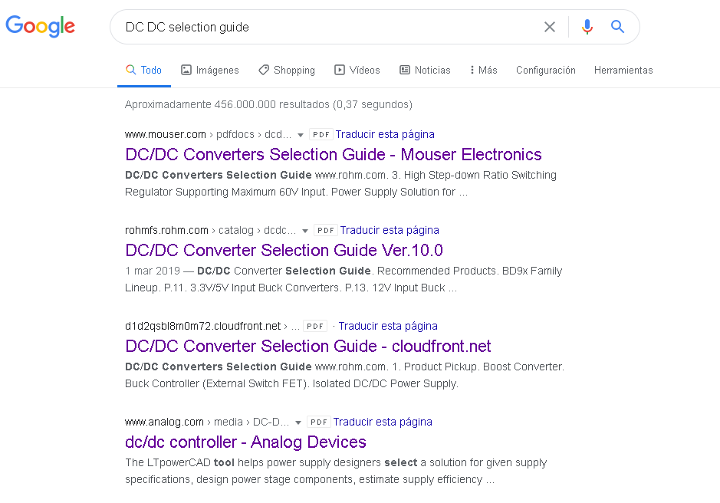
Among these searches, pdfs of manufacturers, sellers, distributors, etc. will appear. That will allow you to locate the exact component. We choose a search to find the following document.
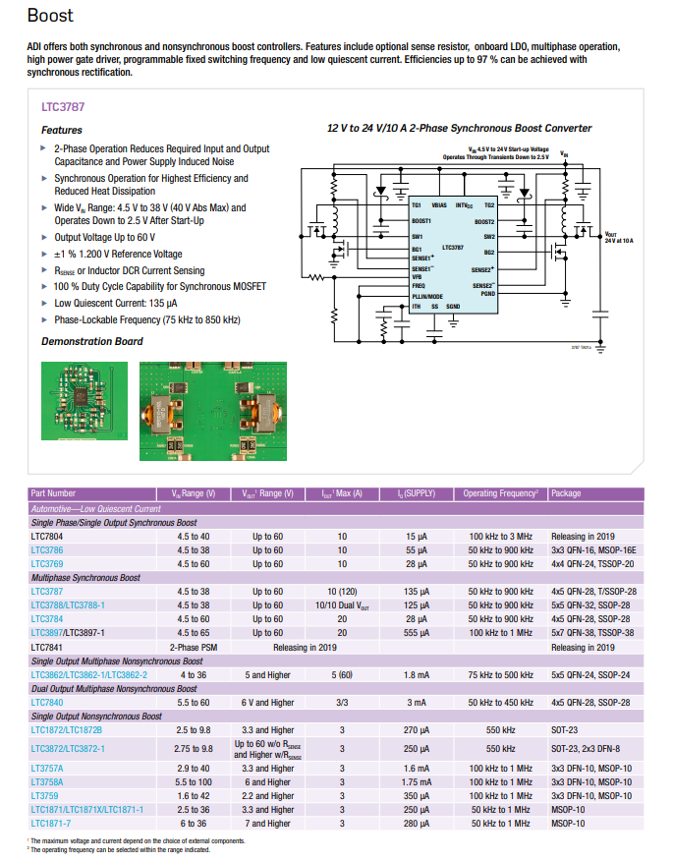
So, among all the devices that appear now, you should choose the most suitable one for the application you want to develop.

